**Celerie Kemble for Mirror Home Dark Mahogany Mirror**

**Price: $2518**

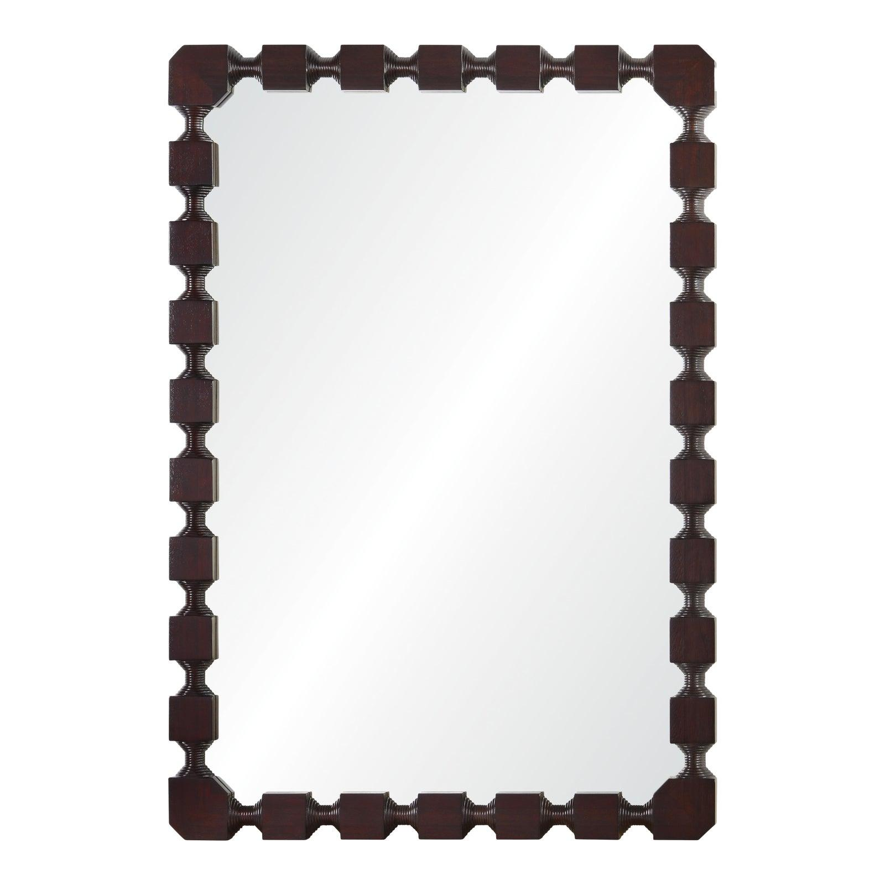

* CATEGORIES

Bathroom mirrors

* MATERIALS

Metal Bordered

* SHAPE

Rectangle

* BRAND

Viglacera